# Lock stock and Barrel Assigment 2 – dylan matthews

Contents

Lock stock and Barrel Assigment 2 – dylan matthews 1

Description 2

Screen shots 3

Login screen to login 3

Register a user 3

Admin screen 4

View stock screen 4

Add stock screen 5

Add stock for an item screen 5

Normal user screen 6

Sell items screen 6

Specification’s 7

Flow chart 8

Help 9

UML 10

Class diagrams 10

# Description

The progam is a stock control system.

It allows an admin to view and add stock.

Normal users can sell stock.

The program won’t allow the stock to get negative.

# Screen shots

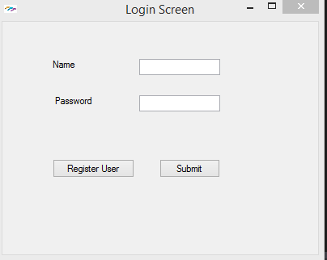

## Login screen to login

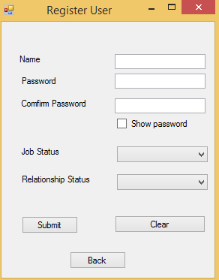

## Register a user

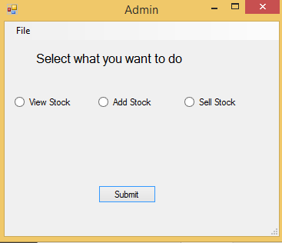

## Admin screen

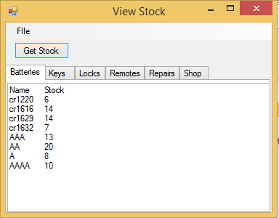

## View stock screen

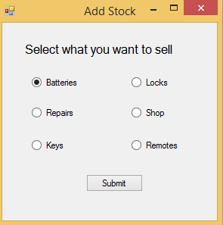

## Add stock screen

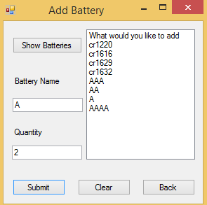

## Add stock for an item screen

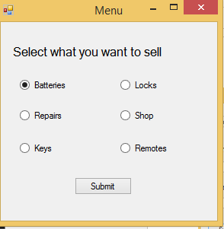

## Normal user screen

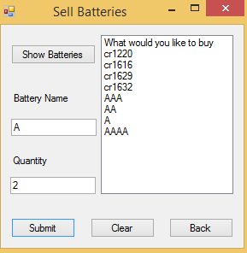

## Sell items screen

# Specification’s

1. Have at least three Forms;

2. Form properties should be changed;

3. Have at least one (1) Button;

4. Have at least one (1) Label;

5. Have at least one (1) TextBox;

6. Have at least one (1) ListBox;

7. Have at least one (1) ComboBox;

8. Have at least one (1) Menu;

9. Have at least one (1) TabControl;

10. Have at least two (2) RadioButtons on the same Form;

11. Have at least two (2) CheckBoxes on the same Form;

12. Write and register appropriate event handler methods that interact appropriately with the controls added to the Form(s).

# C:\Users\15009851\Documents\Flow Chart Assigment 2.pngFlow chart

# Help

Login screen will open on launch.

If you login in with a normal user you will be taken to the selling screen.

From here you select the radio button which you want to sell.

Once you in an item to sell you can see the different items which you can sell.

You then type in the name and amount of stock which you want to sell.

You can exit the application at the top left with the menu button.

If you login with admin

You’ll be taken to the admin screen here you can choose to sell, add , view stock.

If you select selling.

From here you select the radio button which you want to sell.

Once you in an item to sell you can see the different items which you can sell.

You then type in the name and amount of stock which you want to sell.

You can exit the application at the top left with the menu button.

If you select add

From here you select the radio button which you want to add.

Once you in an item to sell you can see the different items which you can add.

You then type in the name and amount of stock which you want to add.

You can exit the application at the top left with the menu button.

From here you select the radio button which you want to sell.

If you select view stock.

You click on the get stock button then select the tab which you want to see the stock of.

# UML

## Class diagrams

